CONSTITUTION AND BYLAWS

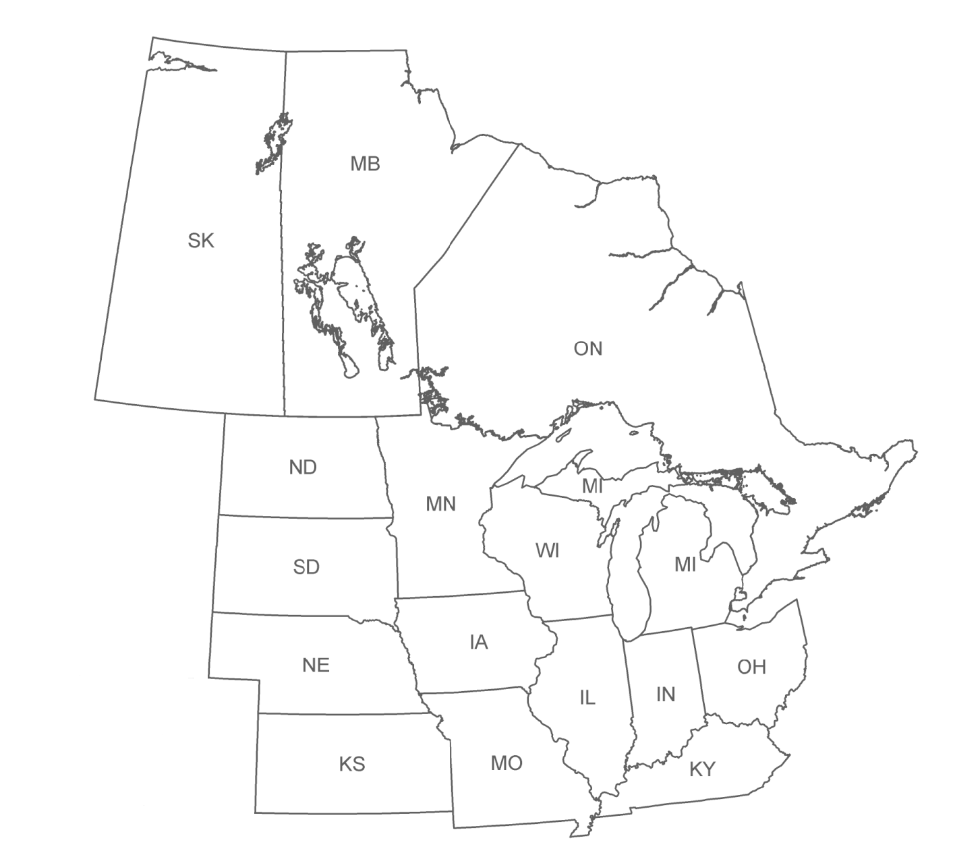

MIDWEST ASSOCIATION OF FISH & WILDLIFE AGENCIES

JUNE, 2016

CONSTITUTION AND BYLAWS
MIDWEST ASSOCIATION OF FISH & WILDLIFE AGENCIES

PREAMBLE

The name of this organization shall be the Midwest Association of Fish and Wildlife Agencies (Association). The Association shall be organized and operated as a non-profit professional association as described in 501(c)(6) of the U.S. Internal Revenue Code with the purpose of promoting the protection, preservation, restoration and management of fish and wildlife resources.

The Conservation Enhancement Fund (Fund) shall be organized and operated as a non-profit charitable organization as described in 501(c)3 of the U.S. Internal Revenue Code.

The Association and the Fund were incorporated in the State of Kansas on August 19, 2005. The Association and the Fund shall comply with K.S.A. 17-1759, et seq., known as the “Charitable Organizations and Solicitations Act.” To the extent these bylaws conflict with a provision of the Act, the Act shall govern.

The objectives of the Association shall be:

(a) to protect the right of jurisdiction of the Midwestern states over their wildlife resources on public and private lands;

(b) to scrutinize carefully state and federal wildlife legislation and regulations and to offer support or opposition to legislative proposals or federal regulations in accordance with the best interests of the Midwestern states;

(c) to serve as a clearinghouse for the exchange of ideas concerning wildlife and fisheries management, research techniques, wildlife law enforcement, hunting and outdoor safety, and information and education;

(d) and to encourage and assist sportsmen's and conservationists' organizations so that the fullest measure of cooperation may be secured from our citizenry in the protection, preservation, restoration and management of our fish and wildlife resources.

The Association met for the first time on October 28, 1934 in Des Moines, Iowa. At that time the group was known as the Association of Midwest Fish and Game Commissioners. The Association first received its non-profit status in 1968. The Association’s name was changed to the Association of Midwest Fish and Wildlife Commissioners in 1972, to the Association of Midwest Fish and Wildlife Agencies in 1977, and to the Midwest Association of Fish and Wildlife Agencies in 2001.

A R T I C L E I

OFFICERS

Section 1. The Officers of the Association shall be President, First Vice-President, and Second Vice-President. The President and both Vice-Presidents shall be the duly authorized voting representative of their member state or province and shall be selected on an alphabetical rotation basis, with the First Vice-President being from the state or province next in order of rotation following the President and the Second Vice-President being from the state or province next in rotation following the First Vice-President. The term of office shall commence 30 days following adjournment of the Association of Fish and Wildlife Agencies’ (AFWA) annual meeting and conclude 30 days following adjournment of the succeeding annual AFWA meeting. The First Vice-President shall automatically succeed to President if he/she remains eligible.

Section 2. The Board of Directors shall be composed of the officers identified in Article I, Section 1 and one representative from each state and province except those represented by the officers. Such state or provincial Board member shall be the chief executive officer of the fish and wildlife agency of his/her state or province, or his/her designee. A Board member may, by written notification to the President, designate a voting proxy from the Board member’s state or province. However, Executive Committee members may not designate a proxy for the conduct of Executive Committee business.

A R T I C L E II

OTHER ASSOCIATION POSITIONS

Section 1. The Association shall establish the position of “Treasurer.” An Association member agency may provide an individual to serve in this capacity or the Association may contract with a member agency or an individual to fill this position. This is a nonvoting position.

Section 2. The Association shall also establish the position of “Executive Secretary.” An Association member agency may provide an individual to serve in this capacity or the Association may contract with a member agency or an individual to fill the position. This is a nonvoting position.

Section 3. The Association may establish the position of “Recording Secretary.” This is a nonvoting position.

A R T I C L E III

MEMBERSHIP

Section 1. Membership shall be by states and provinces and representation of each state and province at meetings shall be by its duly authorized representative or representatives.

Section 2. The area of membership in the Association shall be the states of Illinois, Indiana, Iowa, Kansas, Kentucky, Michigan, Minnesota, Missouri, Nebraska, North Dakota, Ohio, South Dakota, and Wisconsin, and the provinces of Manitoba, Saskatchewan and Ontario and such additional states and provinces as may request membership and be elected by majority vote of the member states and provinces in annual meeting.

Section 3. Membership in the Association of an individual shall terminate upon the expiration of the member's term of office as a state fish and wildlife administrator.

Section 4. Other professional organizations may be granted affiliate membership in the Association based upon demonstration that the Constitution and Bylaws of said organizations meet the basic standards of the Association. Application for affiliate membership shall be forwarded to the Executive Secretary at least 90 days prior to a regular meeting of the Association and shall include a current Constitution and Bylaws and a letter stating the organization's justification for affiliate membership. Affiliate membership shall be voted on by the voting representatives and must attain a majority vote of a quorum. Affiliated membership dues shall be $75.00 per year; however, this fee may be waived by a majority vote of a quorum. The fee is automatically waived for affiliated conservation agencies or organizations that provide annual financial resources to support the Association through the following sponsorships: Major Sponsor ($5,000 or more); Gold Sponsor ($3,000-4,999); Silver Sponsor ($2,000-2,999); Bronze Sponsor ($1,000-1,999); and Sponsor ($500-999).

A R T I C L E IV

DUTIES OF OFFICERS and OTHER POSITIONS

Section 1. The President shall preside at all meetings of the Association, appoint all special committees, preside at meetings of the Board of Directors, and perform such other duties as are naturally incumbent upon the office to serve the Association and the Fund. Copies of the annual proceedings shall be forwarded to each member in good standing, with the cost of preparation and handling to be paid out of Association funds. All other copies are for distribution at the discretion of the host state or province.

Section 2. The First Vice-President shall perform the duties of the President in the latter's absence, and specific duties may be assigned as deemed necessary by the President.

Section 3. The Board of Directors shall conduct the business of the Association.

- Section 4. The Executive Secretary shall perform the following services for the Association and the Fund:

(1) Function as the official “Executive Secretary” for the Association carrying out liaison services by keeping in communication via e-mail, mailings, phone contact and personal visits with member Directors, or their designated representatives, to enhance the viability of the Association.

- Work to obtain direct involvement and commitment of member Directors and affiliate leaders to build strength in the Association as a leading force in the Midwest on behalf of fish and wildlife issues.

- Assist the Executive Director of the Association of Fish and Wildlife Agencies in coordinating actions and communications relevant to the Midwest Association.

- Respond to inquiries for information regarding the Association and the Fund and to routine correspondence.

- Develop and maintain a web site for the Association.

- Carry out directives of the President and/or Executive Committee of the Association.

- Assist with the scheduling of meetings and conference calls and notify appropriate members.

- Record minutes in the absence of the Recording Secretary.

- Provide such other services as may be mutually agreed upon by both parties.

Section 5. The Recording Secretary shall perform the following services:

- Record and publish the annual proceedings of the Association.

- Record and retain the minutes of all meetings of the Association, and perform such other duties as are naturally incumbent upon the office.

- Assist other officers and positions with correspondence and record keeping.

- Serve as the custodian of all permanent files and records of the Association.

- Other duties as assigned by the President.

Section 6. The Treasurer shall perform the following services for the Association and the Fund:

- Be custodian of all funds of the Association and the Fund.

- Establish and have access to Association and Fund bank accounts.

- Draw all warrants for payment of claims properly presented and expend funds necessary to pay appropriately invoiced bills, provided such warrants are signed by a director selected and approved by the Executive Committee.

- Invoice members and sponsors and collect dues and funds.

- Review monthly account reports and monitor income and expenditures.

- Prepare reports to the Executive Committee detailing income, expenditures and asset values.

- Prepare and present annual budgets, financial and audit reports.

- Perform record-keeping, reporting and filing actions to ensure the Association complies with its governing documents and any other relevant laws or regulations, including but not limited to any required filings with the state of Kansas or the Internal Revenue Service to maintain the Association’s status as a tax-exempt non-profit organization and legal entity, and provide a report of any such required actions to the Executive Committee at its next meeting.

- Develop, present and oversee budgets, accounts and financial statements.

- Ensure that appropriate accounting procedures and controls are in place.

- Serve as liaison with any staff and volunteers about Association and Fund financial matters.

- Monitor the Association’s investment activity and ensure its consistency with the Association’s policies and legal responsibilities; liaise with the Investments Committee and review reports submitted thereby.

- Ensure independent examination or audits are executed and any recommendations are implemented; provide report of results at the regular annual meeting.

- Make formal presentation of the accounts at the regular annual meeting and more frequently as requested by the Executive Secretary, the President or the Executive Committee.

A R T I C L E V

MEETINGS

One regular meeting shall be held annually. The meeting will be held in and hosted by the state or province in which the President has administrative responsibility, or in such other locations designated by the Association. It is the intent of the Association that the costs of the annual meetings and related business functions may be paid by the Association. When necessary, special meetings may be called by the President or the Executive Secretary. Members shall be given 90 days’ notice of regular annual meetings; 60 days’ notice for special, in-person meetings; and five days’ notice for special, telephonic meetings and telephonic meetings of the Executive Committee..

The Association may authorize members, affiliates and other groups to exhibit at its meetings, subject to the Exhibitor/Sponsor Policy approved by the Board of Directors.

A R T I C L E VI

VOTING

Voting shall be by states and provinces, as units. Each state and province shall have one vote. All voting shall be by voice vote, except that a reasonable request by any member state or province for a secret ballot shall be honored. Any matters of Association business requiring action in the interim between meetings may be handled by the Executive Committee, by majority vote of that committee.

A R T I C L E VII

DUES

Annual Dues shall be $3,800 per member state and $100 per province, payable in advance, at, or before each annual meeting; provided that annual dues may be suspended for any given year by a majority vote of a quorum. Dues shall be adjusted annually by the Consumer Price Index for All Urban Consumers (CPI-U) in the Midwest published by the United States Bureau of Labor Statistics. Dues shall be adjusted using the annual change in the CPI-U for the month of January of the previous fiscal year. The annual dues for the upcoming year shall be reported at the Association’s regular annual meeting by the Treasurer.

A R T I C L E VIII

FISCAL YEAR

The fiscal year of the Association shall be January 1 through December 31.

A R T I C L E IX

QUORUM

A quorum is defined as a simple majority of the states.

A R T I C L E X

AMENDMENT

The Constitution and Bylaws (Bylaws) of the Association may be amended at any regular meeting by a majority vote of a quorum; provided, however, a written copy of such proposed amendment shall have been received by the President and the Executive Secretary and sent to members at least 30 days before the regular annual meeting or special meeting called for that purpose; and provided that such changes shall be effective only to the extent they are authorized by applicable law. Proposed Bylaws amendments should be presented to, or generated by, the Bylaws Committee and reviewed by the Executive Committee prior to submitting to voting members of the Association for their consideration. With approval of the First Vice-President, the President may call for voting by mail (including electronic mail) in lieu of a meeting. In this event, the 30-day notice shall still apply, the date of opening ballots shall be previously announced, notice sent to each member within forty-eight hours of vote tabulation by the Executive Secretary and all ballots shall be kept for one year following the vote.

A R T I C L E XI

TYPES OF COMMITTEES/BOARDS

Section 1. There shall be three kinds of committees: Standing, President’s Ad Hoc, and Technical Working.

Section 2. The following Standing Committees shall be appointed by the incoming President within 30 days after assuming office, they shall serve during the period intervening between annual meetings and at such meetings, or until the purpose of each such committee has been accomplished and it has been discharged by the President.

- The Executive Committee shall be composed of six members of the Association: The President, First Vice President, Second Vice-President, immediate Past President, and two other members to be appointed by the President with specific consideration for geographical balance. Any state or province represented on the Executive Committee by more than one individual shall be restricted to a single vote on this committee. The Executive Committee shall have general supervision of the affairs of the Association between its business meetings, make recommendations to the Association as necessary and shall perform such other duties as may be specified in these bylaws. The Executive Committee shall be subject to the orders of the Board of Directors and none of its acts shall conflict with action taken by the Board of Directors. Special meetings of the Executive Committee may be called by the President as necessary. The Executive Committee may also act via conference call or by mail (including electronic mail). In the event that an officer of the Association or the immediate Past President separates from a member agency (or is replaced by that agency), their replacement in a member agency shall serve for the remainder of their term.

- The Auditing Committee shall be composed of three members: The First Vice President of the Association, who shall act as chairman, and two other members to be appointed by the President. The Auditing Committee shall audit the financial records of the Association annually and report the result of its audit at the annual regular meeting.

- The Resolutions Committee shall be composed of three members, one of which shall be designated as Chairman by the President. Copies of proposed resolutions should be received by the President and the Executive Secretary and sent to members for their consideration at least 30 days before the regular annual meeting. Courtesy resolutions and resolutions of a last minute nature may be recommended to the Board of Directors at the annual meeting. Furthermore, proposed resolutions for which an urgent need arises between annual meetings may be presented to the Board of Directors for consideration via mail (including electronic mail), provided members are given a 15-day notice. Members shall be notified of the vote outcome by the Executive Secretary within forty-eight hours of vote tabulation.

- The Awards Committee shall be composed of five members, one of which shall be designated as Chairman by the President. The Awards Committee shall administer the official annual awards program of the Association.

- The Bylaws Committee shall be composed of at least one member, designated by the President. The Bylaws Committee shall recommend Bylaws changes to the Executive Committee for consideration.

- The Investments Committee shall be composed of three members. The President shall designate one of the members as Chairman. The purpose of the committee is to review investments, including the Jaschek portfolio, the Conservation Enhancement Fund, and other permanent assets of the Association and make recommendations to the Association per the investment policy statement. The Investments Committee shall make an annual report to the Board of Directors at the annual meeting.

- The Conservation Enhancement Fund shall be overseen by a Board of Directors. The Board of Directors shall be comprised of the Executive Committee plus one additional Association member appointed by the President. The purpose of the Fund shall be to support those activities of the Association which maintain and enhance the capability of all member states and provinces to develop and implement comprehensive fish and wildlife programs for all species of wildlife and their habitats. The Conservation Enhancement Fund Committee shall make recommendations for expenditures from the Fund for consideration by the Board of Directors at the regular annual meeting. The Committee shall report its activities, including no activity in the event there are no funds in the Fund, annually to the Board of Directors when making its recommendations.

- The Program Committee shall be comprised of four members, one from the host state of the previous annual meeting, one from the host state of the current annual meeting, one from the host state of the next annual meeting, and the Executive Secretary. The purpose of the committee is to assist the host state with developing presentation and discussion topics and suggesting speakers for the non-business portion of meeting.

Section 3. Ad Hoc Committees may be established as deemed necessary by the President of the Association or vote of the Members and shall serve until the purpose of each such committee has been accomplished and it has been discharged by the President or by vote of the Members.

Section 4. The Association may establish Technical Working Committees as deemed necessary to conduct the affairs of the Association. Upon establishment, these committees shall adhere to the following:

- Within one year from establishment, each committee shall submit to the Association for approval a Mission Statement, a list of specific responsibilities, and a description of operating procedures that will become part of the official minutes of the Association.

- All Technical Working Committees shall submit a written report electronically to the President and the Executive Secretary 30 days in advance of the annual meeting of the Association and may choose to conduct necessary committee business during the period between annual meetings as per their approved operating procedures.

- Each Technical Working Committee shall be automatically abolished by the first of August every three years unless reinstated by vote of the Association. As the end of the third year approaches, the Association shall assess the merits of reinstating the Technical Working Committee.

- Resolutions from Technical Working Committees for Association action shall be submitted to the Chair of the Resolutions Committee 30 days in advance of the annual meeting for consideration by the Board of Directors.

The Association recognizes the following Technical Working Committees (year of automatic abolishment in parentheses):

Climate Change (2019)
Legal Committee (2017)
National Conservation Need (NCN) Committee (2017)
Midwest Private Lands Wildlife Management Group (2018)
Midwest Public Lands Technical Working Committee (2019)
Midwest Wildlife and Fish Health Committee (2019)
Midwest Deer and Wild Turkey Study Group (2017)
Association of Midwest Fish and Game Law Enforcement Officers (2017)
Midwest Furbearer Group (2018)
Wildlife Action Plan Technical Working Committee (2018)
Hunter and Angler Recruitment and Retention Technical Working Group (2017)

A R T I C L E XII

PARLIAMENTARY AUTHORITY

The rules contained in the current edition of Robert’s Rules of Order Newly Revised shall govern the Association in all cases to which they are applicable and in which they are not inconsistent with these bylaws and any special rules of order the Association may adopt.

Adopted 1936
Amended 1942
Amended 1944
Amended 1949
Amended 1954
Amended 1960
Amended 1964
Amended 1969
Amended 1971
Amended 1972
Amended 1975
Amended 1976
Amended 1977
Amended 1978
Amended 1980
Amended 1987
Amended 1993
Amended 1995
Amended 1996
Amended 2000
Amended 2001
Amended July 16, 2003
Amended July 13, 2004
Amended July 13, 2005
Amended July 12, 2006
Amended July 18, 2007
Amended July 2, 2008
Amended July 1, 2009
Amended December 23, 2009
Amended June 29, 2011
Amended June 27, 2012
Amended June 26, 2013
Amended June 25, 2014
Amended July 1, 2015
Amended June 29, 2016

