2017 State of the State Report for Ohio

New licenses system goes into effect
Ohio’s new online licensing system went live at the end of February. The new Ohio Wildlife Licensing System (OWLS) replaces the previous online system which had been in use since 2009. The new system, built by Sovereign Sportsman Solutions LLC, is more economical, user friendly, and considerably more powerful than the system it replaces.

LEPMAG model continues to pay dividends
The Lake Erie Percid Management Advisory Group (LEPMAG), a stakeholder-based structured decision process, is continuing work to guide harvest policy of yellow perch on Lake Erie. LEPMAG formed in 2011 to guide harvest control rules for walleye, which are an important commercial fishery in Canada and important sport fisheries in Michigan, Ohio, Pennsylvania, and New York, who do not allow commercial walleye fisheries. With the completion of the walleye component of this effort, work began more than two years ago to continue the LEPMAG efforts and guide policy and harvest strategies for yellow perch fisheries. The yellow perch process is entering its third year, and similar to the walleye process, is facilitated by Mike Jones of the Michigan State University Quantitative Fisheries Center and supported by the Great Lakes Fisheries Commission. Ohio’s positive experience with the LEPMAG process has encouraged the Division of Wildlife to initiate an SDM approach for incorporating stakeholder interests in a 10-year white-tailed deer management plan (see the next topic below).

Deer stakeholders group begins work on 10-year deer management plan
Ohio continues to be nationally recognized for exceptional deer hunting - providing good hunter success rates, high-scoring bucks, and a diversity of opportunities. Effectively managing these hunting opportunities is a challenge that requires the best possible understanding of the varied views, opinions, and interests among sportsmen and landowners, in addition to science-based management. The Division of Wildlife is preparing for the future of deer management by developing a Deer Management Plan that involves substantial contributions from stakeholder organizations. The purpose of the plan is to provide a 10-year framework for managing huntable deer populations based on historical perspectives, stakeholder interests, and science-based management.

The stakeholder group included representatives from the following:
- Ohio Conservation Federation
- Ohio Bowhunters Association
- Ohio Outdoor Writers Association
- Whitetails Unlimited
- Quality Deer Management Association
- Ohio Farm Bureau
- Buckeye Big Bucks Club
- Buckeye Firearms Association
- Social Media
- League of Ohio Sportsmen
- Ohio Forestry Association
- The Nature Conservancy
- The Ohio State University
- Ohio Farmers Union
- Ohio Senate
- Ohio Wildlife Council
- Ohio Dept. of Agriculture
- Private Forestry Consultant
- Whitetail Deer Farmers of Ohio

Pollinators - OPHI
In response to the Monarch listing petition, the Ohio Pollinator Habitat Initiative (OPHI) was formed. This partnership includes the Ohio Division of Wildlife, US Fish and Wildlife Service, Ohio Department of Transportation, The Ohio State University - Extension, Ohio Department of Agriculture, USDA Farm Service Agency, Pheasants Forever/Quail Forever, and many other conservation organizations across the state.

In partnership with the Ohio Pollinator Habitat Initiative (OPHI):

- The first Pollinator/Monarch Symposium was held in Columbus to raise awareness of the plight of these species. Over 350 people attended.

- A statewide milkweed pod collection was conducted. DOW Private Lands Biologists were instrumental in the transportation of pods from County SWCDs to various prisons across the state for pod and seed processing. Over 2,500 gallons of pods were collected.

- In cooperation with ODOT, a “How-To” manual was developed for establishing roadside pollinator & Monarch habitat.

- Work began to develop Monarch/pollinator habitat with non-traditional partners such as ODOT, AEP, First Energy, golf courses, County & State parks, and Marathon Petroleum.

- Division of Wildlife private lands biologists working in cooperation with the United States Department of Agriculture’s Farm Services Agency, will implement and assist landowners enrolling in the new CRP Pollinator/Monarch SAFE program. This SAFE project covers 43 Ohio counties with an enrollment allotment of 30,000 acres of habitat for pollinators and the Monarch butterfly.

Orphan wildlife program – Born Wild Stay Wild Campaign
Division of Wildlife staff are spending an increasing amount of time dealing with situations involving animals taken from the wild. These situations often do not end well, and social media has allowed some situations to elevate animals to “celebrity” status.
This program’s purpose is to establish an agency-wide plan to be proactive.
Key components in the development of this program were to research other state/organization programs, identify key messages, identify target demographic, and ultimately identify how best to communicate and connect with public.
Campaign messages were distributed through expanded content on our website, increased use of social media, special publications, newspaper ads, and posters and displays at public events.

Some of the messaging included the following images:
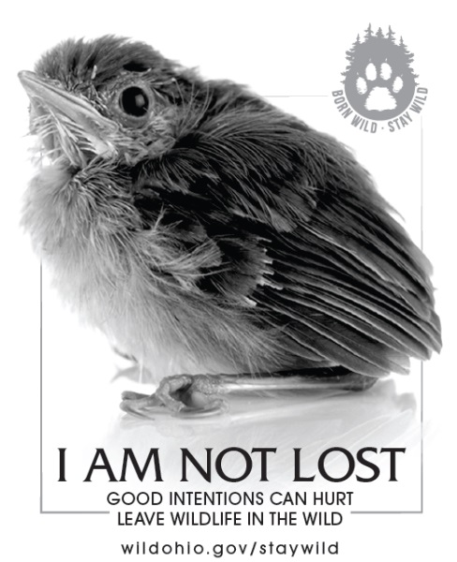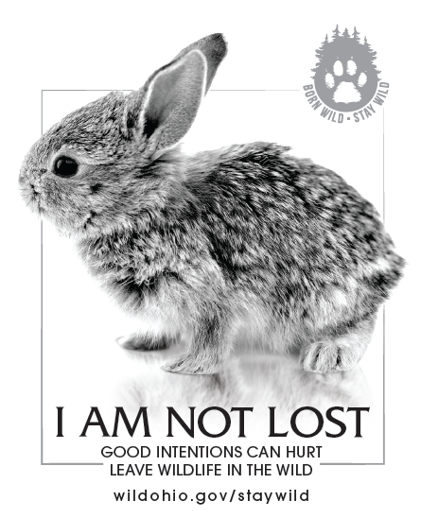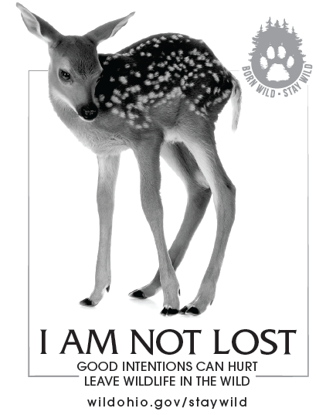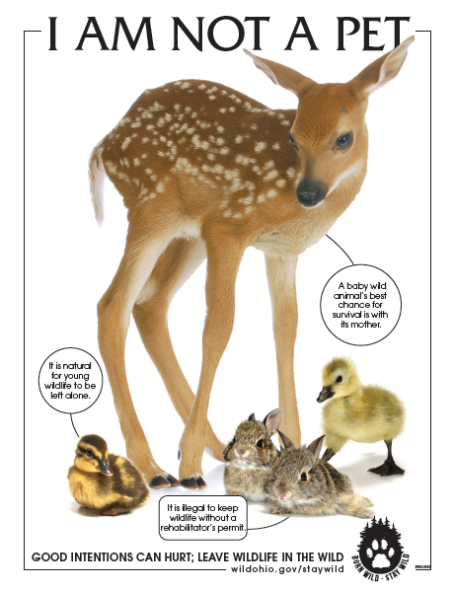

Last year of whitetail disease surveillance area (DSA)
A CWD positive deer detected in a captive herd in Holmes County, Ohio in 2015 resulted in the Division of Wildlife implementing a DSA in 11 townships surrounding the facility where the CWD positive was detected. All deer harvested during the gun and muzzleloader seasons from within the DSA had to be taken to inspection stations for CWD sampling. The DSA remains in place for 3 consecutive years, assuming no additional CWD positive deer are found. With two years of no positive detects behind us, the 2017 deer hunting season will be the final year of the DSA in place. Compliance (harvested deer brought to inspection stations) during the first year was 60%, but dropped to 30% in the second year.

